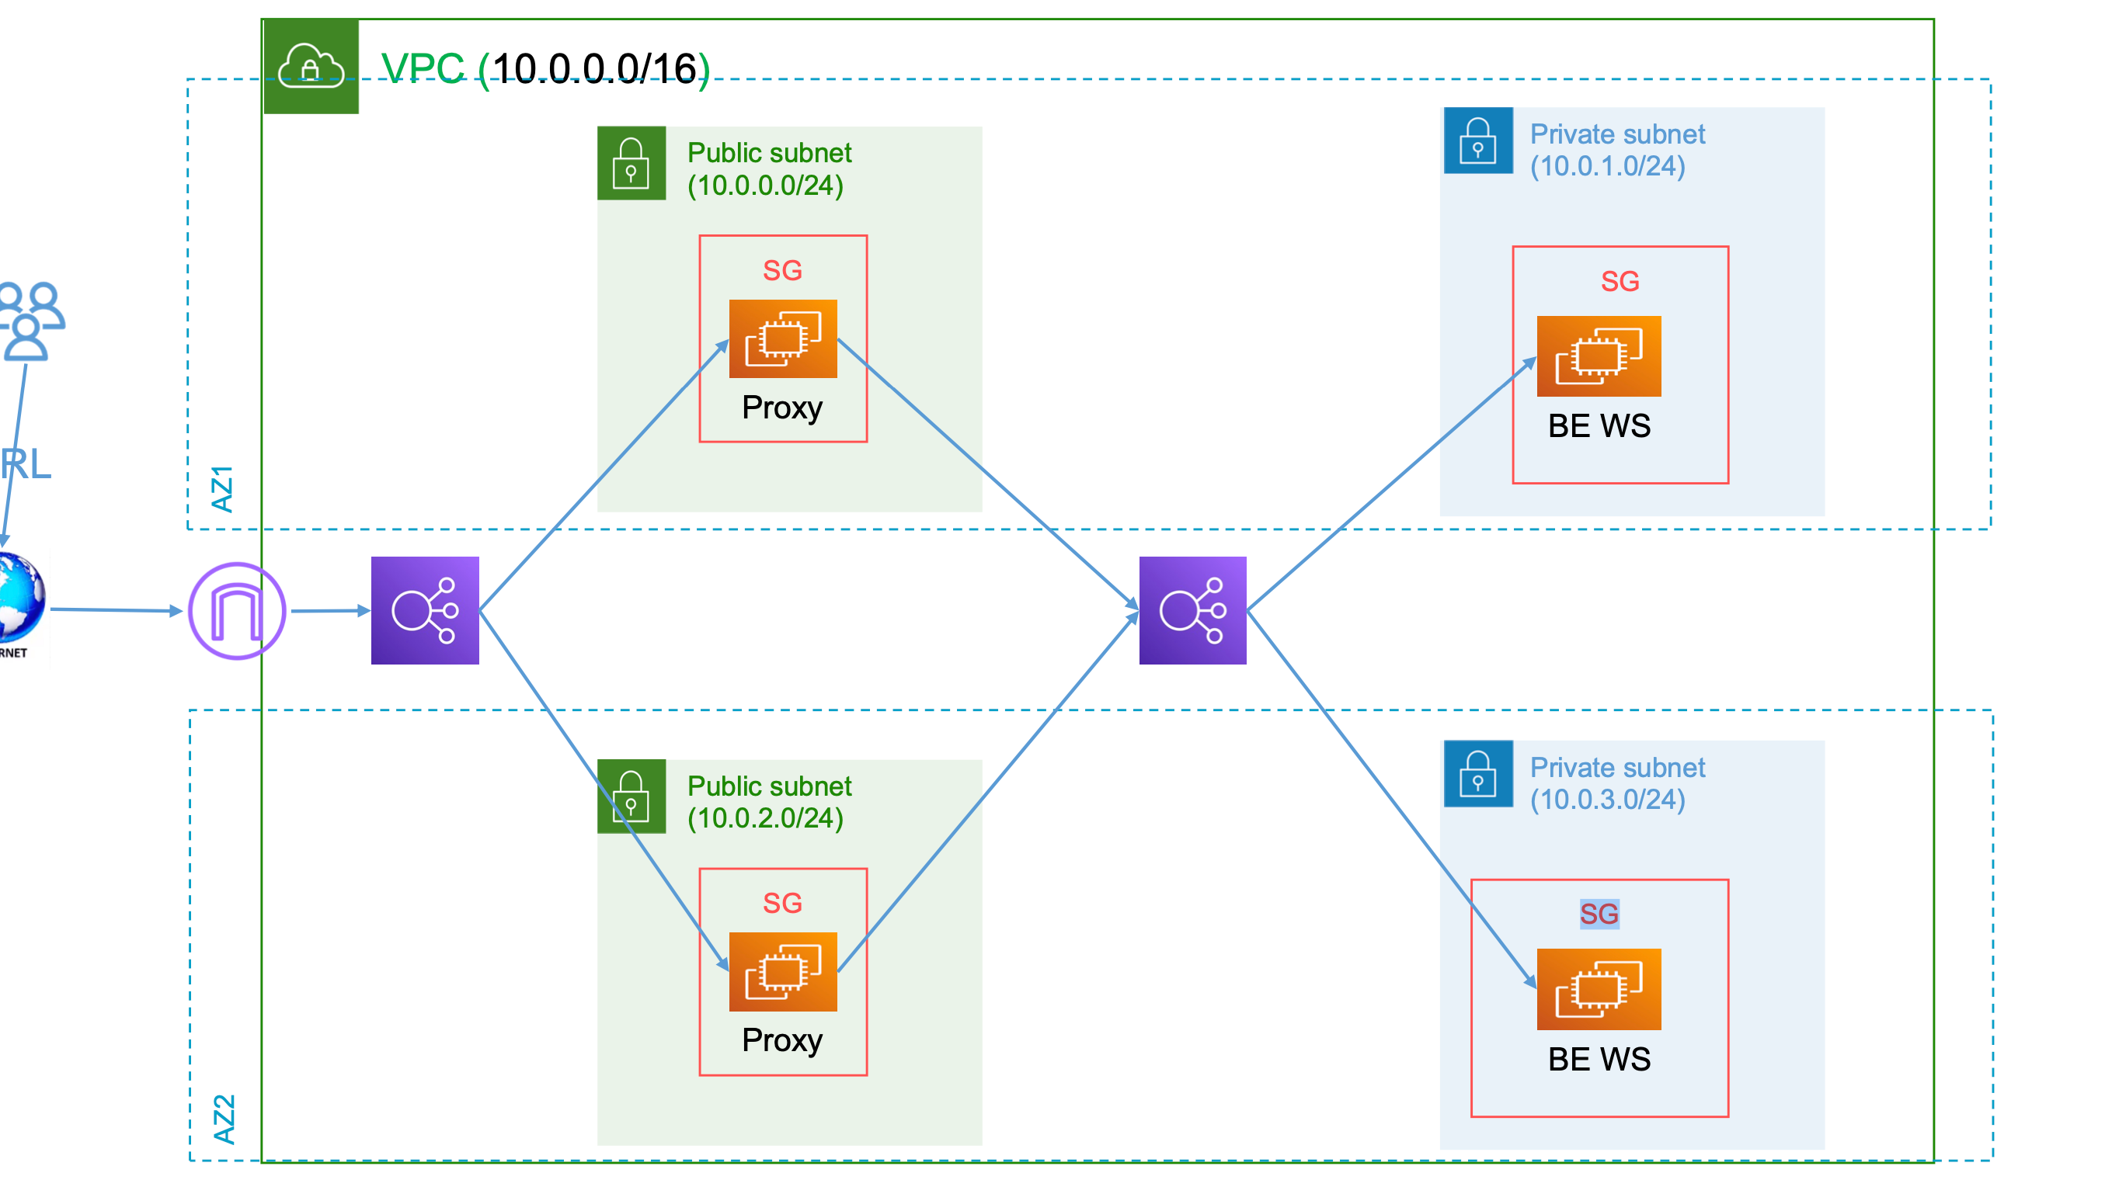

Lab3
- Launch a jump host
  - Take a screen while you are ssh to the jumphost
  - Also When you ssh from bastion to the private machine
  - Screenshot from the console showing the instances Ips
- Implement the below diagram then
- take a screenshot while you put dns of the load balancer into the browser and it returns a response from the 2 apache instatnces
- Also Screenshot from the console showing the machines BE WS have private Ips
- And finally a screenshot showing the targets of the 2 loadbalancers target groups are healthy
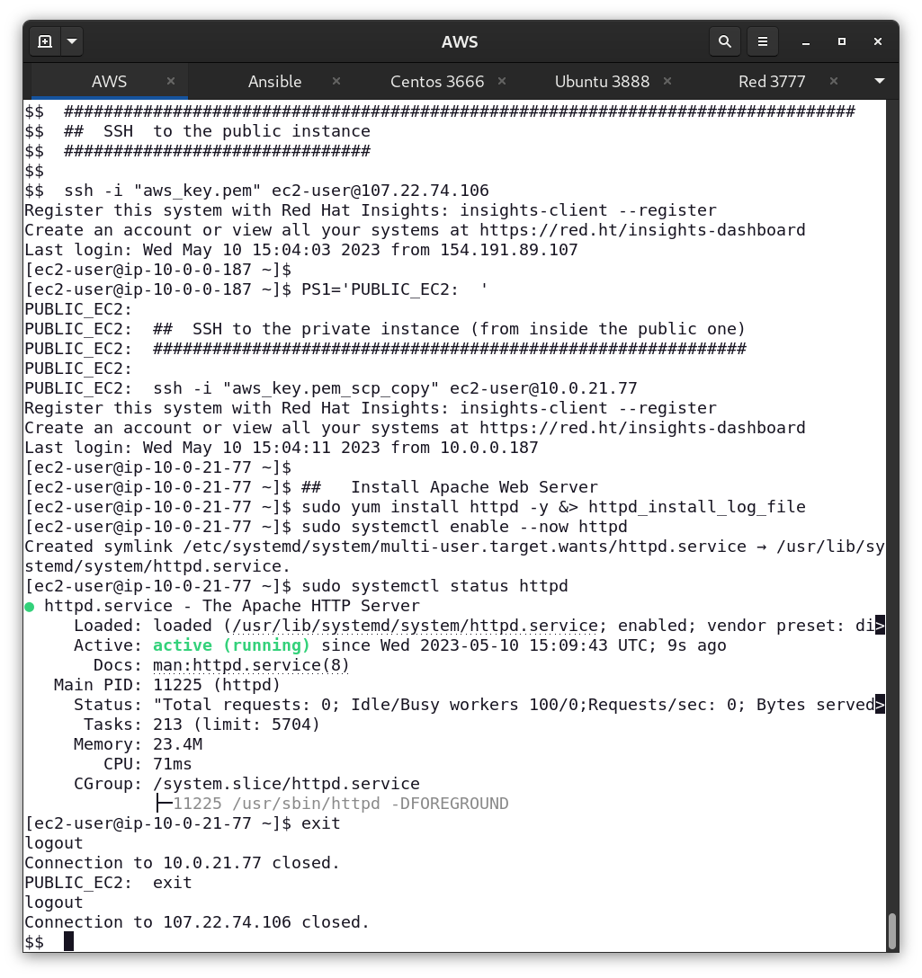
- Launch a jump host
  - Take a screen while you are ssh to the jumphost
  - Also When you ssh from bastion to the private machine

  - Screenshot from the console showing the instances Ips
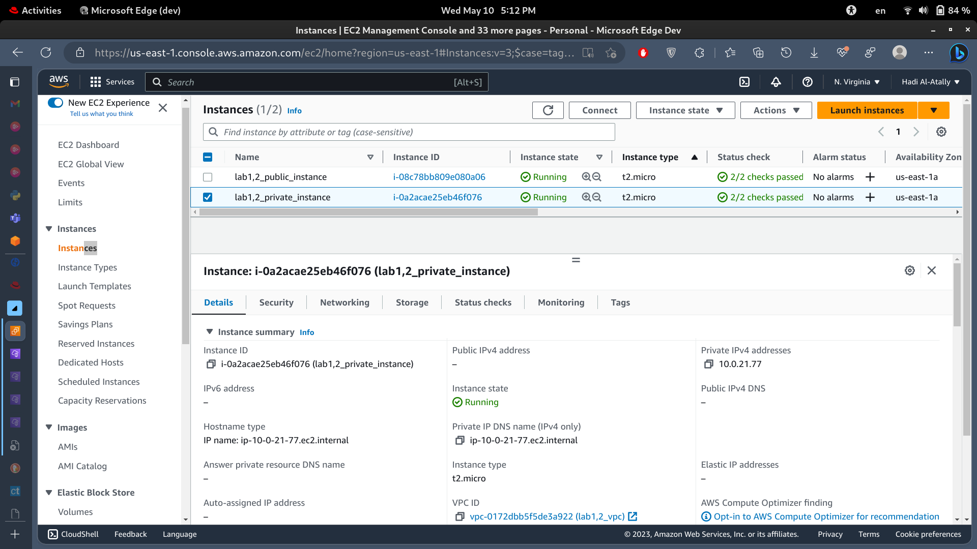
Addition: using user data section to enter an intialization script.
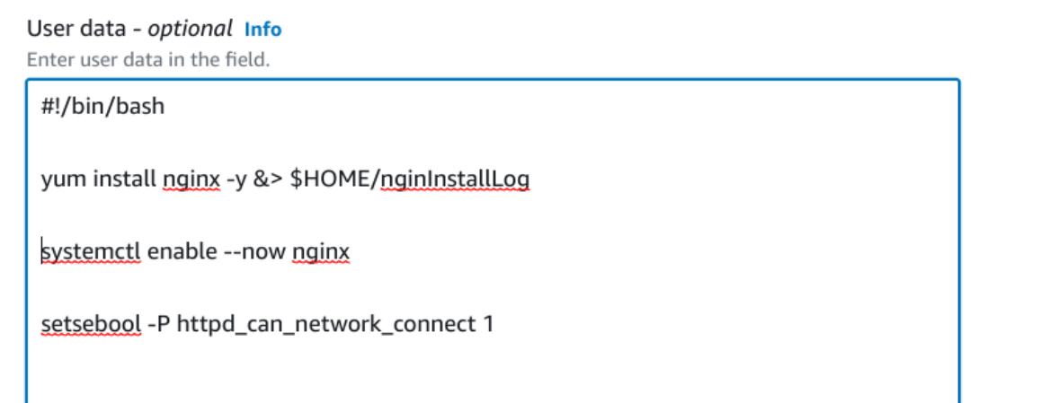
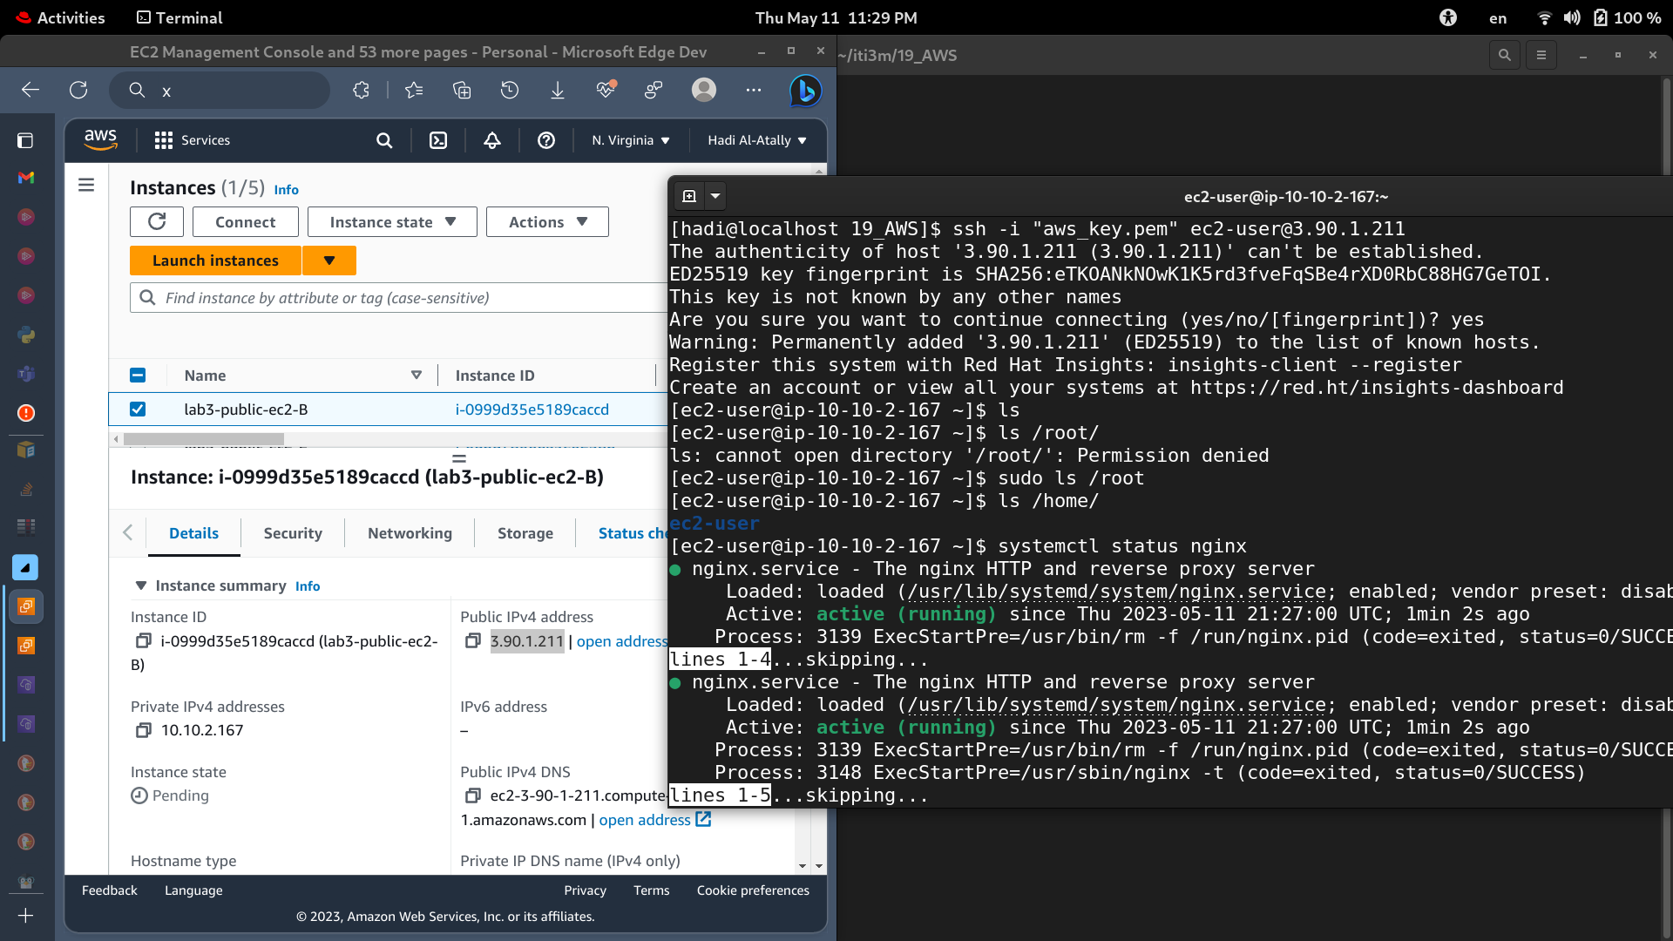
- Implement the below diagram then
- take a screenshot while you put dns of the load balancer into the browser and it returns a response from the 2 apache instatnces
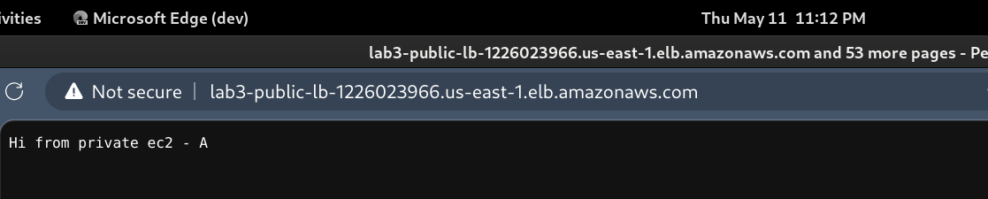
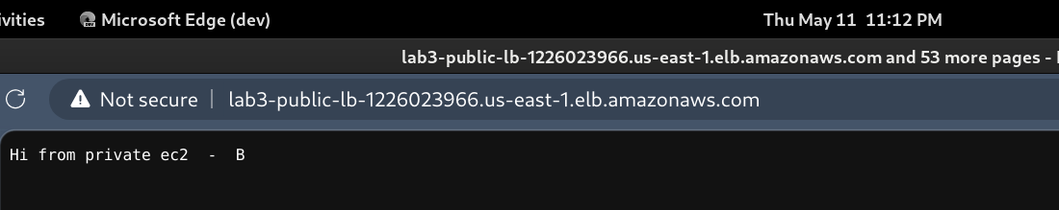

- Also Screenshot from the console showing the machines BE WS have private Ips

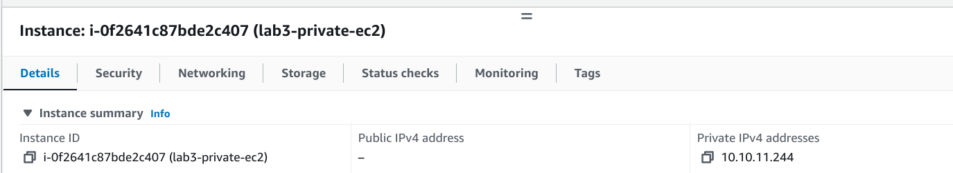
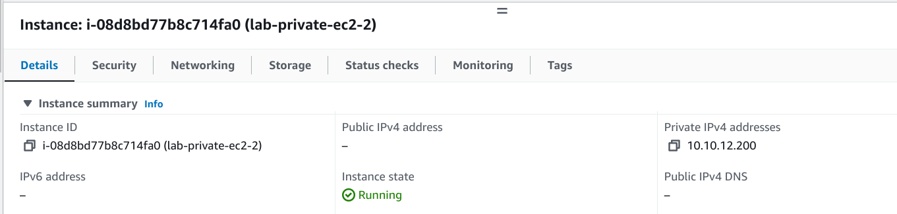

- And finally a screenshot showing the targets of the 2 loadbalancers target groups are healthy
